上學期期中考 姓名:___________
huí dá wèn tí
一、回答問題：(Answer the questions according to the text in the textbook.)
píng
- 蘋果能使誰充滿活力？
__ ____________________
píng kě
- 蘋果能使誰不怕口渴？
___ _____________________
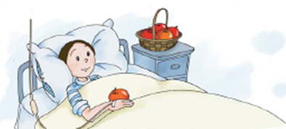
píng
- 蘋果能使誰有信心？
___ ___________________

tián tián kàn zài lián lián kàn
二.填填看再連連看： (Fill in the blanks according to the festivals with their
customs.)

gāo
拿紅包、吃年糕
wàn shèng jié
萬 聖 節

bǐng
吃月餅、看月亮

jī cān
吃火雞大餐

dēng lóng
做南瓜燈籠

三、Fill in the blank according to its English meaning.
to participate
to like
exam.
safe and sound
forever

四、Look at the pictures and fill in the blanks.

_____

______

____

____

_____

__相機

____ ____ ____ ____

chóng zǔ
五、重組：(Put the words in order to make a sentence. )
1. ＊開學第一天的 一百分。 明明 考試， 得了
＊

2. ＊安安 中文， 喜歡說 中文歌。 也喜歡唱
＊

3. ＊今天 去參加 明明 生日會。 友友的
＊

quān cí zài xiě yí biàn
六. 圈詞再寫一遍：(Circle the following characters to make words or phrases
and write them in the blanks with their English meaning.)

活 | 運 | 生 | 氣
平 | 動 | 永 | 溫
安 | 全 | 遠 | 久
日 | 節 | 照 | 亮
活動 activity

pīn pīn kàn

七. 拼拼看：(Put two characters together to make a new character and
make a word or phrase for the new character .)

- 弓 ＋ 長

- 言 ＋ 式

- 原 ＋ 頁

4.巾 ＋ 冒

yòng yīn wèi suǒ yǐ zào jù
八.用“因為..所以..”造句：(Make a sentence according to the given pictures
with “因為..所以..”.)




